**There are 2 ways.**

1. Go to setup and click Monitoring and you can check your debug logs.

2. Go to developer console ,In below pane you can see ' Logs ' tab ,click on it to see log details.

Ex:How to put debug logs in apex class:

Public class MyHelloWorld {

// initialization datatypes

// declaration of methods

MyHelloWorld(){

System.debug('Welcome to Apex world');

}

}

**Ex:How to put debug logs in triggers:**

trigger MyHelloWorld on <SObject>(Events){

// Here write business logic.

System.debug('Welcome to Apex trigger world');

}

Please follow the below steps,if you want see the debug log output.

Way 1

Navigation:

Go to your name and click on developer console in dropdown.Please see the below screenshot

Go to developer console ,In below pane you can see ' Logs ' tab ,click on it to see log details.

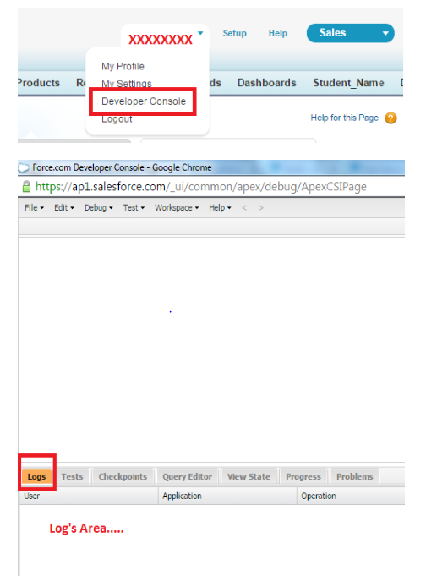

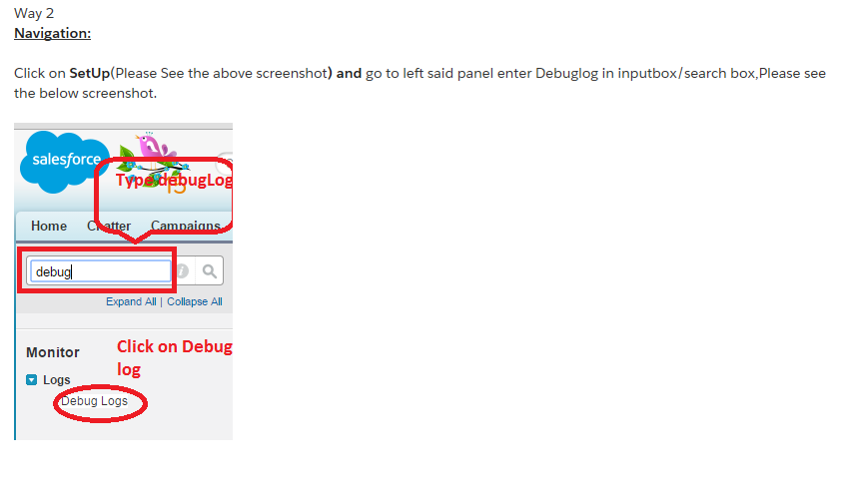

<https://developer.salesforce.com/docs/atlas.en-us.apexcode.meta/apexcode/apex_debugging_system_log_console.htm>